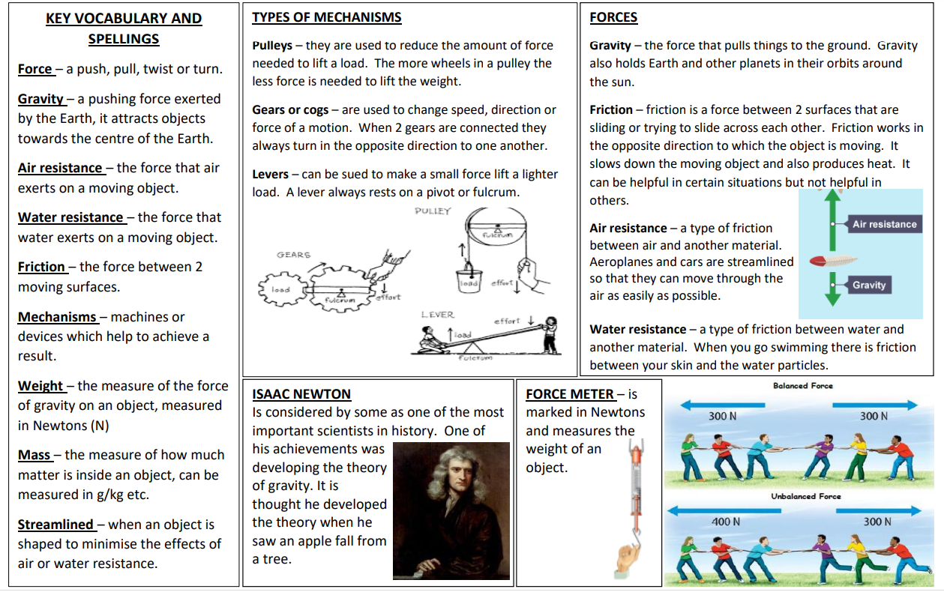

Knowledge Organiser – Year 5