Year 5 Geography Knowledge organiser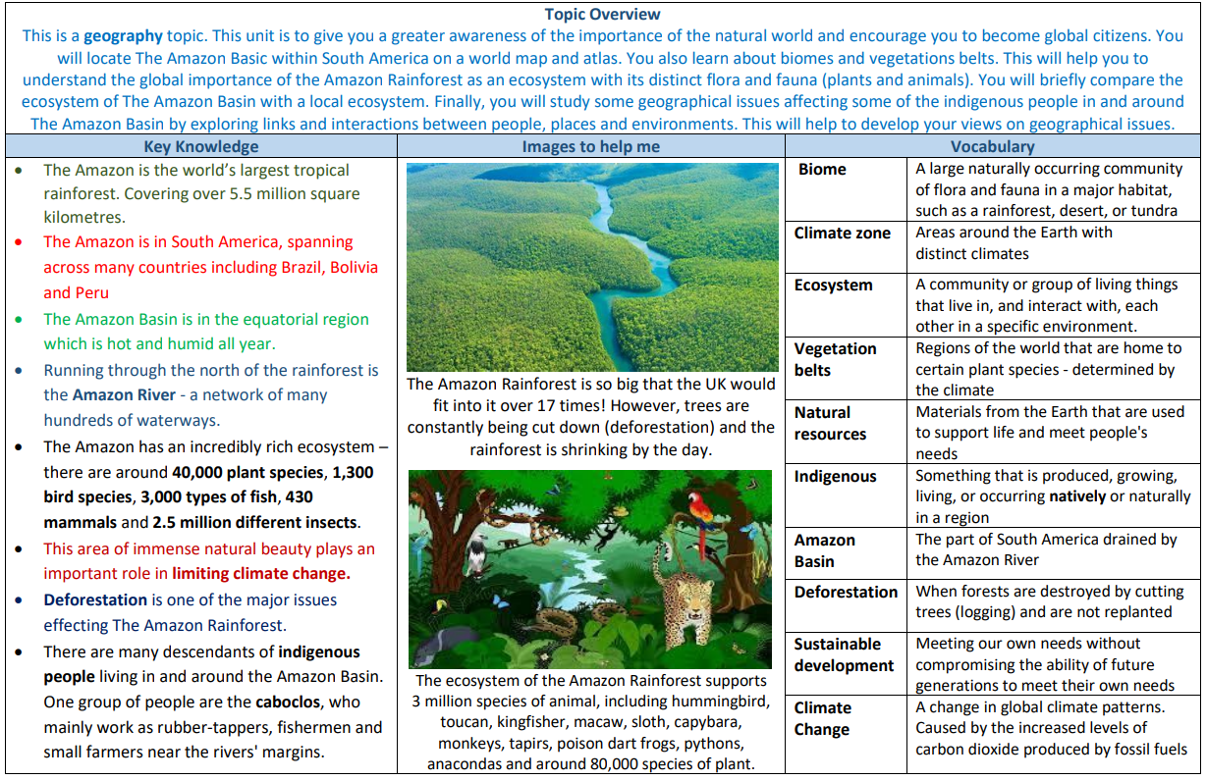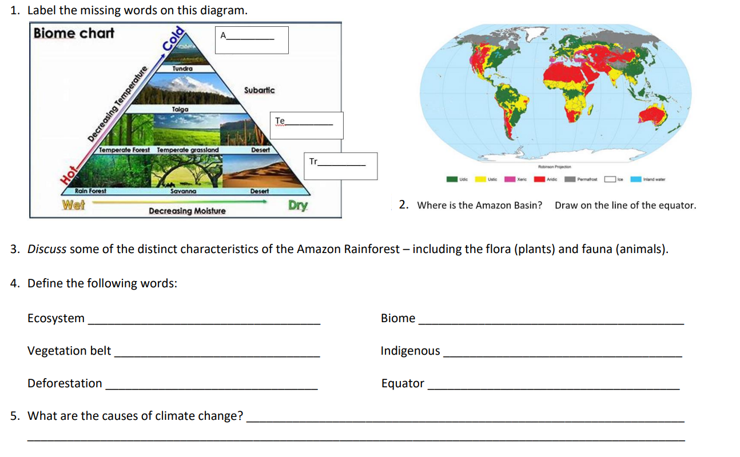

Year 5 Geography Knowledge organiser